**Example 9.6:**

Design a Turing machine over {1, b} which can compute a concatenation function over ∑= {1}. If a pair words (w1, w2) is the input. The output has to be w1w2.

**Solutions**

-Let the input TM diagram be:

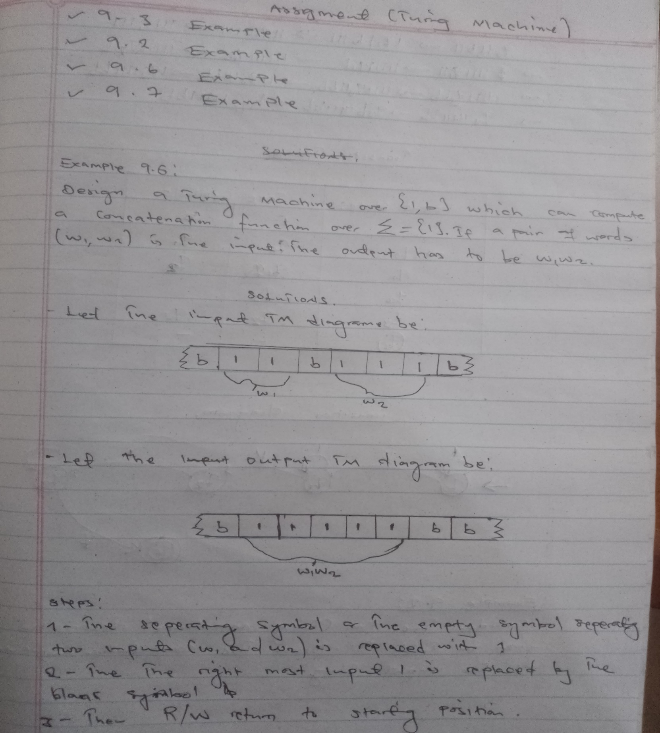

Let the output TM diagram be:

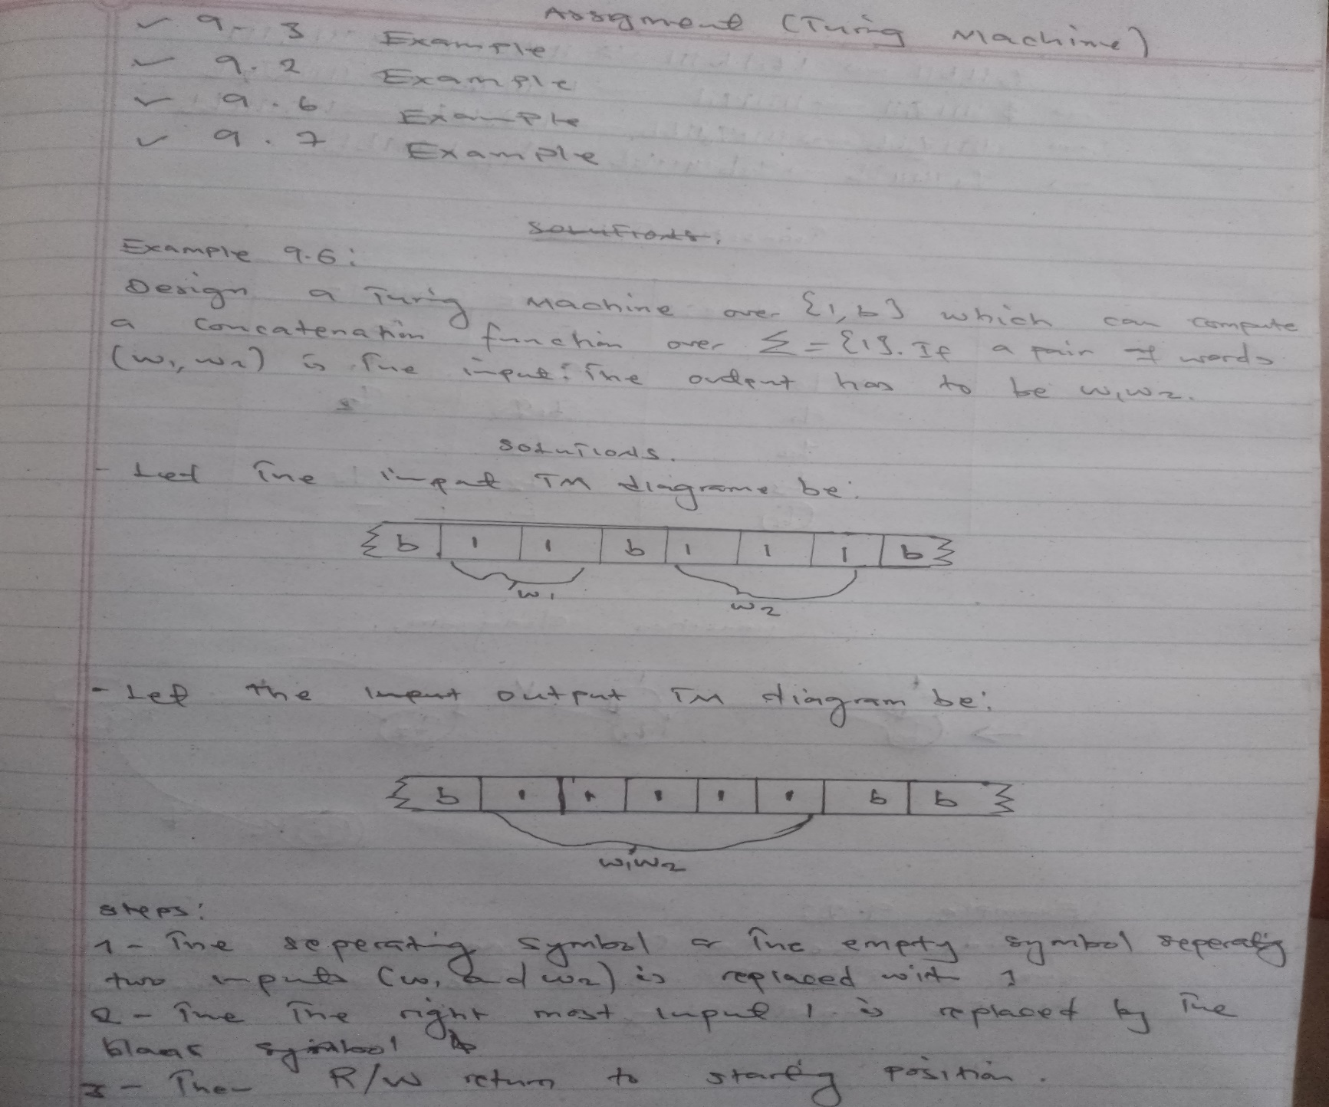

**Steps**:

1. The separating symbol or the empty symbol separating two inputs is (w1 and w2) is replaced 1.
2. The right most input 1 is replaced by the blank symbol.
3. Then R/W return to the starting position.

**Production:**

q011b11 1q01b111 11q0b111 111q1111

q01111q111 11111q11 111111q1b 11111q21b

1111q31bb 111q311bb 11q3111bb 1q31111bb

q311111bb q3b11111bb q411111bb

**Transition Table**

|  |  |  |
| --- | --- | --- |
| **Present state** | **Tape Symbol** | |
|  | **1** | **b** |
| **q0** | **q0** | **q1** |
| **q1** | **q1** | **q2** |
| **q2** | **q3** | **-** |
| **q3** | **q3** | **qf** |
|  | **-** | **-** |

**Transition Diagram**

